

Project Name: ONLINE VEHICLE SERVICE STATION

Branch: PG-DAC - Sept 2021.

Documentation On

**“ONLINE VEHICLE SERVICE STATION”**

PG-DAC Sept 2021

**Guided By: Bakul Joshi**

Submitted By:

**Group No: 10**

* **Rutuja Malvadkar 210943020048**
* **Omkar Badhe 210943020060**
* **Saurabh Jagtap 210943020084**
* **Harshal Gunjal 210943020113**

**Table of Contents**

**1. Introduction 4**

1.1 Document Purpose **4**

1.2 Project Background **4**

1.3 Aim & Objectives **4**

**2. Business Requirements Overview**…………………………………………………………**5**

**3.Functional Requirements** **5**

3.3 Admin Module **6**

3.1 Customer Module **5**

3.2 Owner Module **6**

3.3 Employee Module **6**

**4.** **Non-Functional Requirement………………………………………………………………6**

**5. Use Case Diagram 7**

5.1 Admin **7**

5.2 Customer **8**

5.3 Owner **9**

5.4 Employee **10**

**6. Database Design 11**

1 Login **11**

2 Area **11**

3 City……………………………………………………………………………………… **11**

4 Questions **11**

5 Customer **12**

6 Owner **12**

7 Admin **12**

8 Employee **13**

9 Service **13**

10 Service_details **13**

11 Service_request **14**

12 Service_request_details **14**

13 Stock **14**

14 Category **14**

15 Vehicle_details **15**

16 Feedbacks **15**

17 Invoice **15**

**7. E-R Diagram………………………………………………………………………………………16**

**8. Snapshots 17**

**9. Conclusion 25**

**List of Figures**

**Use Case Diagrams 7**

Fig 1 Admin 7

Fig 2 Customer 8

Fig 3 Owner 9

Fig 4 ER Diagram 12

1. **Introduction:**
   1. **Document Purpose:**

This document explains the system requirements and scope for developing Online Vehicle Service Station.

Online Vehicle Service Station could divide the four main parts, Customer part , Owner part, Admin part and the Employee part.

This document describes the system requirement of the Account part.

## Project Background:

The purpose of this project is to provide car or any other automobile servicing system more effectively than the existing system. There are some disadvantages of the existing service center management systems. These disadvantages are overcome by the online Vehicle service station. And it can be made handily available to every person. Previously people could not get help or locate the service centers conveniently in case of their car break-down or any other emergencies. Thus, online Vehicle service station is proposed to assist people and fulfill their requirements easily.

## Aim & Objectives:

* The main objective of this project is to build a website which will help Customer to book the appointment for their vehicle servicing/repairing.
* Through Webapp or portal Customers can register through OVSS portal and can also select their nearby service station.

1. **Business Requirements Overview:**

* Online Vehicle service station is a web application.
* There are mainly two types of users. One is the Normal peoples who has vehicle and other is garage owners.
* Customers can find nearest garage which provide authentic service.
* Using this system, garage owners will be able to maintain customer and services data
* Online Vehicle service station System provides the functions which connect the customer and the garage owners efficiently.
* Online Vehicle service station System could be maintained by Administrator.

# Functional Requirements Overview:

Online Vehicle Service Station consists of four modules described as below.

1. Admin Module
2. Customer Module
3. Owner Module
4. Employee Module

# **3.1 Admin Module**

* + Admin can register and create his own account.
  + System provides the function to Admin to manage all owners.
  + Admin could view and delete all the feedbacks provided by customers.

# **Customer Module**

* Customer can register and create his own account.
* System provides the function which allows Customer to find out the services provided and can access invoice generated by garage owners.
* Customer could provide feedbacks through system about the overall experience.

# **3.3 Owner Module**

* Owner can login to his own account.
* Owner can list and manage all the employees working under them.
* Owners can list and manage all the employees working under them.
* Owner can confirm request of customer and create staff accounts.
* Owners can have access to manage and update the stock.
* Owners could have access to all the customers data they have provided services to.
* Owners could have access to all the feedbacks provided by customer.
  1. **Employee Module**
* Employee can Login and Edit his own account.
* Employee could create invoice, update service status and add services with the help of system.
* By this system employee could list, update, add the stocks available.
* Employee could have access to all the customers data they have provided services to. and could delete, update, add the data.

1. **Non-Functional Requirement:**

* The website should use professional design, look and feel and color scheme.
* Users will have no limitations for accessing the application through Internet. The portal being an internet application, it is difficult specify exact number of visitor or users. Hence, we will target the system to support between 5 and 10 million users on launch of phase 1.
* Being a public website, the site must follow general usability guidelines for menus, navigation, colors, links and other actions provided on the screens.
* The system should be designed in such a manner that user will be able to complete tasks in minimum number of steps.

## 5. Use-Case Diagram

**5.1 Admin:**

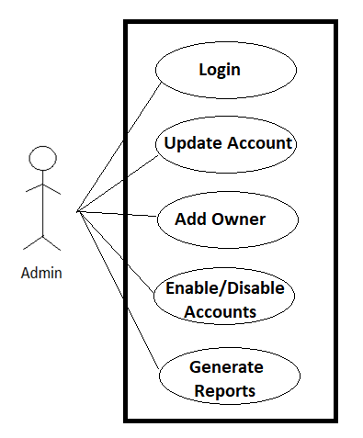

Fig. Use-Case Diagram for Admin

## 5.2 Customer:

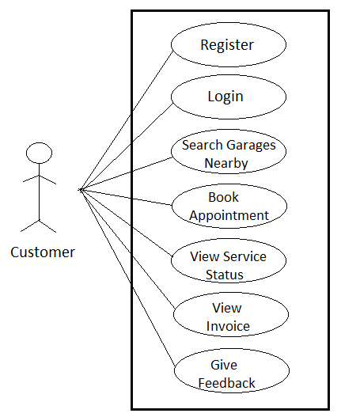

Fig. Use-Case Diagram for Customer

**5.3 Owner:**

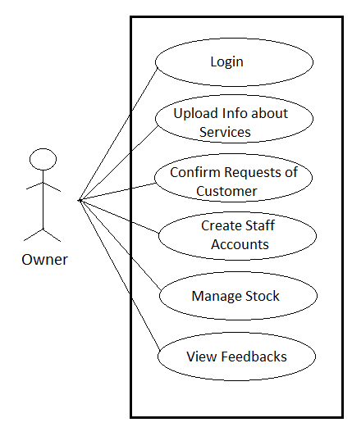

Fig. Use-Case Diagram for Owner

**5.4 Employee**

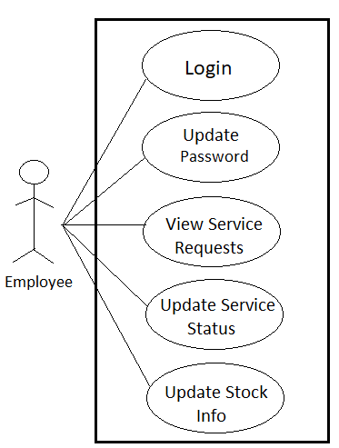

Fig. Use-Case Diagram for Owner

**6. Database Design:**

**1] login table**

|  |  |  |  |  |  |  |
| --- | --- | --- | --- | --- | --- | --- |
| **Field** | **Type** | **Null** | **Key** | **Other** | **Default** | **MAINTAINED IN** |
| **userID** | INT | NO | PRIMARY KEY | AUTO_INCREMENT | NOT NULL | - |
| **email** | VARCHAR(15) | NO | - | UNIQUE | NOT NULL | - |
| **password** | VARCHAR(15) | NO | - | - |  | - |
| **userType** | VARCHAR(15) | NO | - | - |  | - |
| **isactive** | INT | NO | - | - |  | - |
| **questionID** | INT | NO | FOREIGN KEY | - |  | as questionID in questions |
| **answer** | VARCHAR(15) | NO | - | - |  | - |

**2] area table**

|  |  |  |  |  |  |  |  |
| --- | --- | --- | --- | --- | --- | --- | --- |
| **Field** | **Type** | **Null** | **Key** | | **Other** | **Default** | **MAINTAINED IN** |
| **areaID** | INT | NO | | PRIMARY KEY | AUTO_INCREMENT | NOT NULL | - |
| **areaNM** | VARCHAR | NO | - | | - |  | - |
| **cityID** | INT | NO | FOREIGN KEY | | - | NOT NULL | as cityID in city |

**3] city table**

|  |  |  |  |  |  |  |
| --- | --- | --- | --- | --- | --- | --- |
| **Field** | **Type** | **Null** | **Key** | **Other** | **Default** | **MAINTAINED IN** |
| **cityID** | INT | NO | PRIMARY KEY | AUTO_INCREMENT | NOT NULL | - |
| **cityNM** | VARCHAR | NO | - | - |  | - |

**4] questions table**

|  |  |  |  |  |  |  |
| --- | --- | --- | --- | --- | --- | --- |
| **Field** | **Type** | **Null** | **Key** | **Other** | **Default** | **MAINTAINED IN** |
| **questionID** | INT | NO | PRIMARY KEY | AUTO_INCREMENT | NOT NULL | - |
| **question** | VARCHAR(45) | NO | - | UNIQUE | NOT NULL | - |

**5] customer table**

|  |  |  |  |  |  |  |
| --- | --- | --- | --- | --- | --- | --- |
| **Field** | **Type** | **Null** | **Key** | **Other** | **Default** | **MAINTAINED IN** |
| **customerID** | INT | NO | PRIMARY KEY | AUTO_INCREMENT | NOT NULL | - |
| **firstName** | VARCHAR (20) | NO | - | - |  | - |
| **middleName** | VARCHAR (20) | YES | - | - | NULL | - |
| **lastName** | VARCHAR (20) | NO | - | - |  | - |
| **contact** | VARCHAR (10) | NO | - | UNIQUE | NOT NULL | - |
| **address** | VARCHAR (100) | NO | - | - |  | - |
| **userID** | INT | NO | Foreign Key | - | NOT NULL | as userID in login |
| **areaID** | INT | NO | Foreign Key | - | NOT NULL | as areaID in area |

**6] owner table**

|  |  |  |  |  |  |  |
| --- | --- | --- | --- | --- | --- | --- |
| **Field** | **Type** | **Null** | **Key** | **Other** | **Default** | **MAINTAINED IN** |
| **ownerID** | INT | NO | PRIMARY KEY | AUTO_INCREMENT | NOT NULL | - |
| **ownerName** | VARCHAR (45) | NO | - | - |  | - |
| **addressLine1** | VARCHAR (45) | NO | - | - |  | - |
| **addressLine2** | VARCHAR (200) | NO | - | - |  | - |
| **areaID** | INT | NO | Foreign Key | - | NOT NULL | as areaID in area |
| **pincode** | INT | NO | - | - |  | - |
| **contact** | VARCHAR (200) | NO | - | UNIQUE | NOT NULL | - |
| **userID** | INT | NO | Foreign Key | - | NOT NULL | as questionID in questions |

**7] admin table**

|  |  |  |  |  |  |
| --- | --- | --- | --- | --- | --- |
| **Field** | **Type** | **Null** | **Key** | **Other** | **Default** |
| **admin_id** | INT | NO | PRIMARY KEY | AUTO_INCREMENT | NOT NULL |
| **firstName** | VARCHAR | NO | - | - | NOT NULL |
| **lastName** | VARCHAR | NO | - | - | NOT NULL |

**8] employee table**

|  |  |  |  |  |  |  |
| --- | --- | --- | --- | --- | --- | --- |
| **Field** | **Type** | **Null** | **Key** | **Other** | **Default** | **MAINTAINED IN** |
| **emp_id** | INT | NO | PRIMARY KEY | AUTO_INCREMENT | NOT NULL | - |
| **ownerID** | INT | NO | Foreign Key | - | NOT NULL | owner as owne**rID** |
| **firstName** | VARCHAR | NO | - | - |  | - |
| **lastName** | VARCHAR | NO | - | - |  | - |
| **address** | VARCHAR | NO | - | - |  | - |
| **contact** | VARCHAR | NO | - | UNIQUE | NOT NULL | - |
| **joindate** | DATE | NO | - | - | CURRENT_DATE | - |
| **userID** | INT | NO | Foreign Key | - | NOT NULL | as userID in login |

**9] service table**

|  |  |  |  |  |  |
| --- | --- | --- | --- | --- | --- |
| **Field** | **Type** | **Null** | **Key** | **Other** | **Default** |
| **service_id** | INT | NO | PRIMARY KEY | AUTO_INCREMENT | NOT NULL |
| **service_name** | VARCHAR(45) | NO | - | UNIQUE | NOT NULL |
| **category_id** | INT | NO | FOREIGN KEY | - | NOT NULL |

**10] service_details table**

|  |  |  |  |  |  |  |
| --- | --- | --- | --- | --- | --- | --- |
| **Field** | **Type** | **Null** | **Key** | **Other** | **Default** | **MAINTAINED IN** |
| **servicedetID** | INT | NO | PRIMARY KEY | AUTO_INCREMENT | NOT NULL | - |
| **service_id** | INT | NO | FOREIGN KEY | - | NOT NULL | service as **service_id** |
| **ownerID** | INT | NO | FOREIGN KEY | - | NOT NULL | owner as **ownerID** |
| **price** | Float | NO | - | - |  | - |
| **description** | VARCHAR (15) | YES | - | - | NULL | - |

**11] service_request table**

|  |  |  |  |  |  |  |
| --- | --- | --- | --- | --- | --- | --- |
| **Field** | **Type** | **Null** | **Key** | **Other** | **Default** | **MAINTAINED IN** |
| **order_id** | INT | NO | PRIMARY KEY | AUTO_INCREMENT | NOT NULL | - |
| **customerID** | INT | NO | FOREIGN KEY | - | NOT NULL | customer as customerID |
| **ownerID** | INT | NO | FOREIGN KEY | - | NOT NULL | owner as ownerID |
| **vehicleID** | INT | NO | FOREIGN KEY | - | NOT NULL | vehicle_details as vehicleID |
| **emp_id** | INT | NO | FOREIGN KEY | - | NOT NULL | employee as emp_**id** |
| **order_status** | VARCHAR | NO | - | - |  | - |
| **Requested**  **date** | DATE | NO | - | CURRENT_DATE | NOT NULL | - |
| **servicing_date** | DATE | NO | - | CURRENT_DATE | NOT NULL | - |

**12] service_request_details table**

|  |  |  |  |  |  |  |
| --- | --- | --- | --- | --- | --- | --- |
| **Field** | **Type** | **Null** | **Key** | **Other** | **Default** | **MAINTAINED IN** |
| **ser_req_det_id** | INT | NO | PRIMARY KEY | AUTO_INCREMENT | NOT NULL | - |
| **order_id** | INT | NO | FOREIGN KEY | - | NOT NULL | service_request as order_id |
| **service_id** | INT | NO | FOREIGN KEY | - | NOT NULL | service as service_id |

**13] stock table**

|  |  |  |  |  |  |  |
| --- | --- | --- | --- | --- | --- | --- |
| **Field** | **Type** | **Null** | **Key** | **Other** | **Default** | **MAINTAINED IN** |
| **stockID** | INT | NO | PRIMARY KEY | AUTO_INCREMENT | NOT NULL | - |
| **stock_name** | VARCHAR(45) | NO | - | UNIQUE | NOT NULL | - |
| **stock_price** | FLOAT | NO | - | - |  | - |
| **stock_qty** | INT | NO | - | - |  | - |

**14] category table**

|  |  |  |  |  |  |  |
| --- | --- | --- | --- | --- | --- | --- |
| **Field** | **Type** | **Null** | **Key** | **Other** | **Default** | **MAINTAINED IN** |
| **category_id** | INT | NO | PRIMARY KEY | AUTO_INCREMENT | NOT NULL | - |
| **category_name** | VARCHAR(45) | NO | - | UNIQUE | NOT NULL | - |
| **category_desc** | VARCHAR(45) | NO | - | - | NOT NULL | - |

**15] vehicle_details table**

|  |  |  |  |  |  |
| --- | --- | --- | --- | --- | --- |
| **Field** | **Type** | **Null** | **Key** | **Other** | **Default** |
| **vehicleID** | INT | NO | PRIMARY KEY | AUTO_INCREMENT | NOT NULL |
| **customerID** | INT | NO | FOREIGN KEY | - | NOT NULL |
| **vehiclenumber** | VARCHAR (45) | NO | - | UNIQUE | NOT NULL |
| **company** | VARCHAR (45) | NO | - | - | NOT NULL |
| **model** | VARCHAR (45) | NO | - | - | NOT NULL |
| **vehicle_type** | VARCHAR (45) | NO | - | - | NOT NULL |
| **Field** | **Type** | **Null** | **Key** | **Other** | **Default** |
| **vehicleID** | INT | NO | PRIMARY KEY | AUTO_INCREMENT | NOT NULL |
| **customerID** | INT | NO | FOREIGN KEY | - | NOT NULL |

**16] feedbacks table**

|  |  |  |  |  |  |  |
| --- | --- | --- | --- | --- | --- | --- |
| **Field** | **Type** | **Null** | **Key** | **Other** | **Default** | **MAINTAINED IN** |
| **feedbackID** | INT | NO | PRIMARY KEY | AUTO_INCREMENT | NOT NULL | - |
| **customerID** | INT | NO | FOREIGN KEY | - | NOT NULL | customer as customerID |
| **ownerID** | INT | NO | FOREIGN KEY | - | NOT NULL | owner as ownerID |
| **feedback_text** | VARCHAR | NO | - | - | NOT NULL | - |
| **createdOn** | TIMESTAMP | NO | - | - | CURRENT_TIMESTAMP | - |

**17] invoice table**

|  |  |  |  |  |  |  |
| --- | --- | --- | --- | --- | --- | --- |
| **Field** | **Type** | **Null** | **Key** | **Other** | **Default** | **MAINTAINED IN** |
| **invoiceID** | INT | NO | PRIMARY KEY | AUTO_INCREMENT | NOT NULL | - |
| **date** | DATE | NO | - | CURRENT_DATE | NOT NULL | - |
| **order_id** | INT | NO | FOREIGN KEY | - | NOT NULL | service_request as order**_id** |
| **customerID** | INT | NO | FOREIGN KEY | - | NOT NULL | customer as customerID |
| **totalBill** | FLOAT | NO | - | - | NOT NULL | - |

## 7. ER-Diagram:

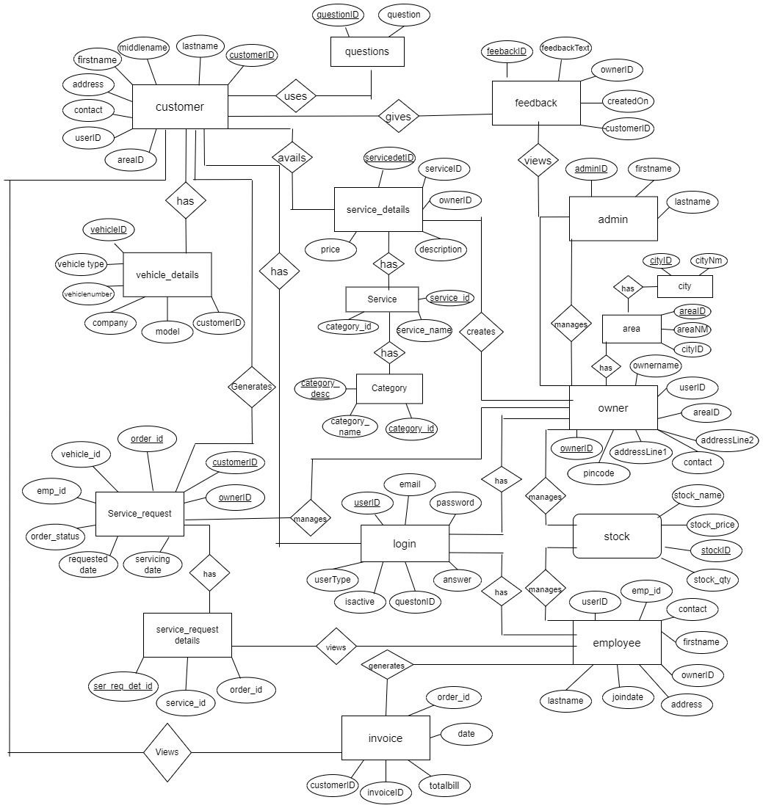

**E-R diagram shows database of Online Vehicle Service Station**

**8. Snapshots:**

**8.1 Home Page:**

Following snapshot shows the Home page for Online Vehicle Service Station

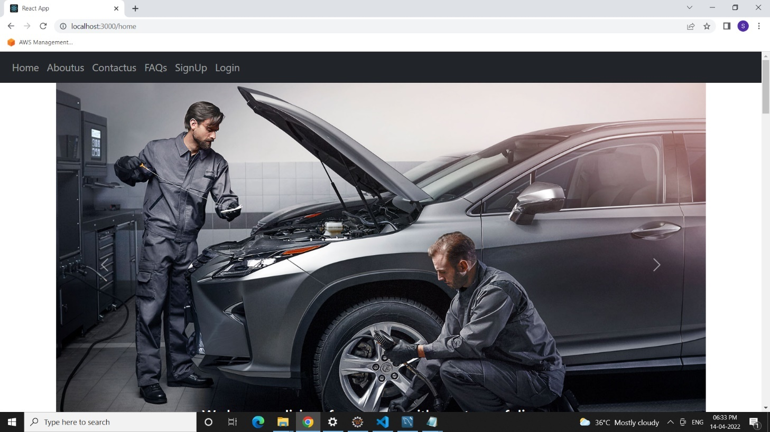

This page contains following controls

* Home
* About Us
* Contact Us
* Sign Up (Customer )
* Sign In
* FAQ’s

**8.2 Contact And About Page**

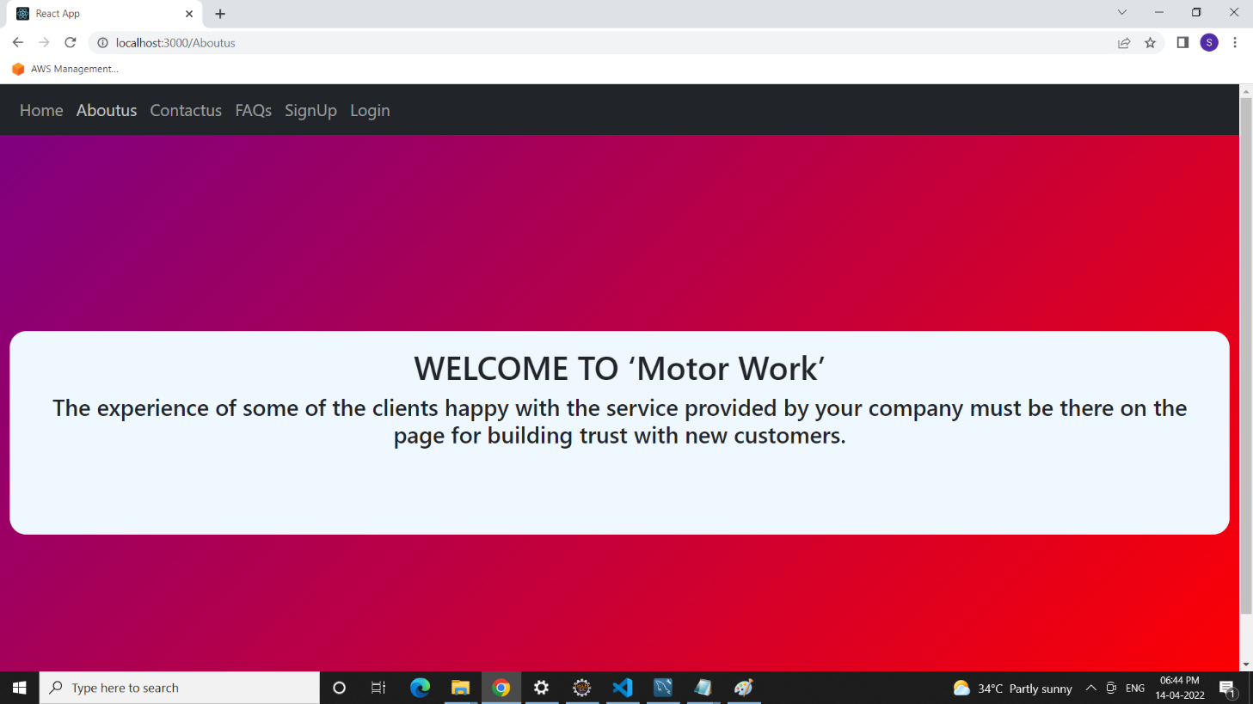

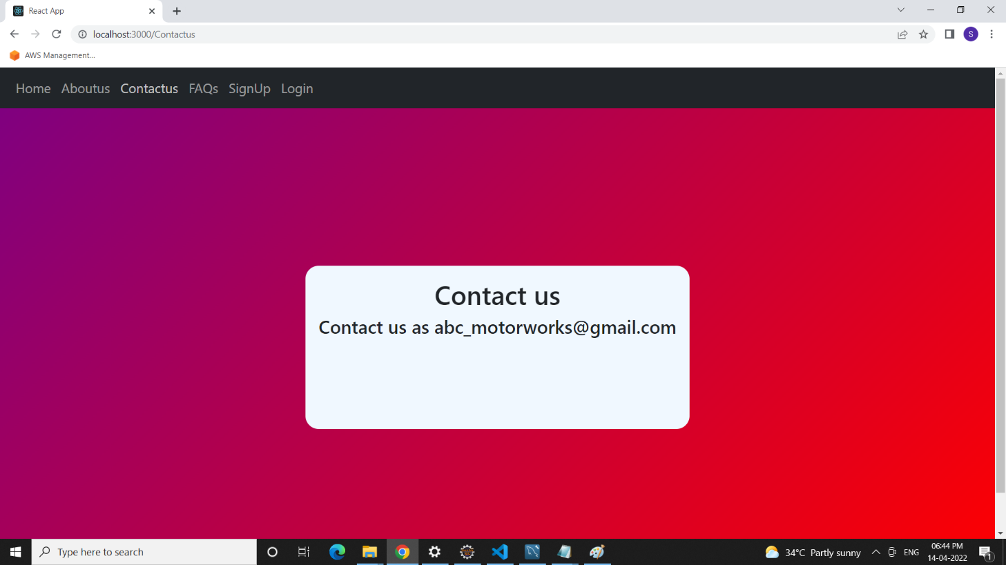

**8.3 FAQ’s Page**

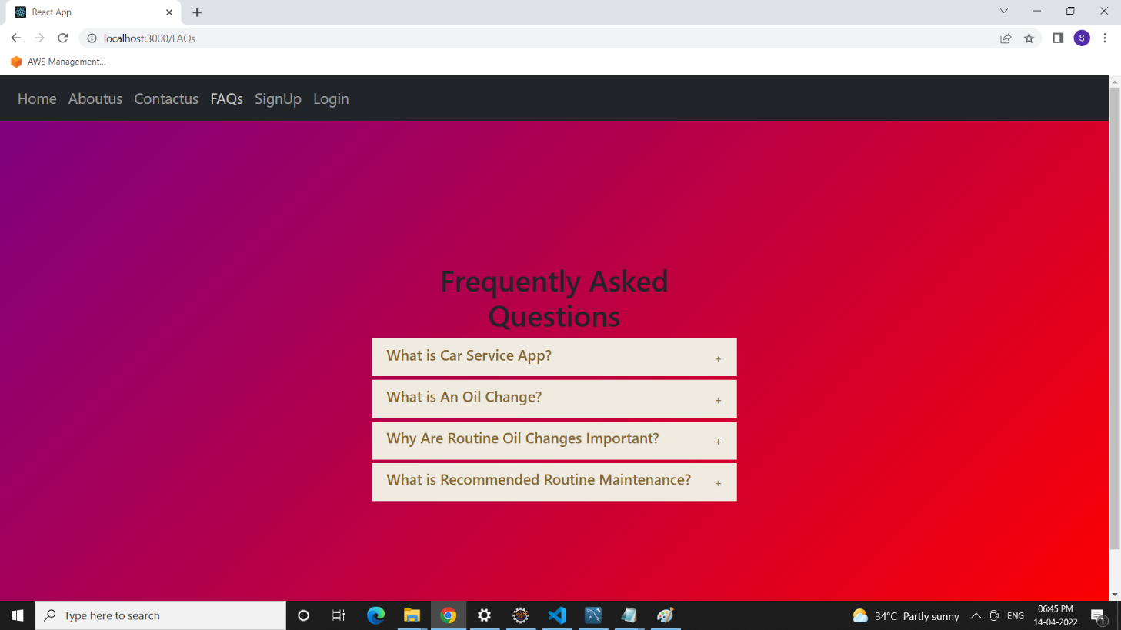

**8.4 Login Page**

Following snapshot shows the Login page for Online Vehicle Service Station

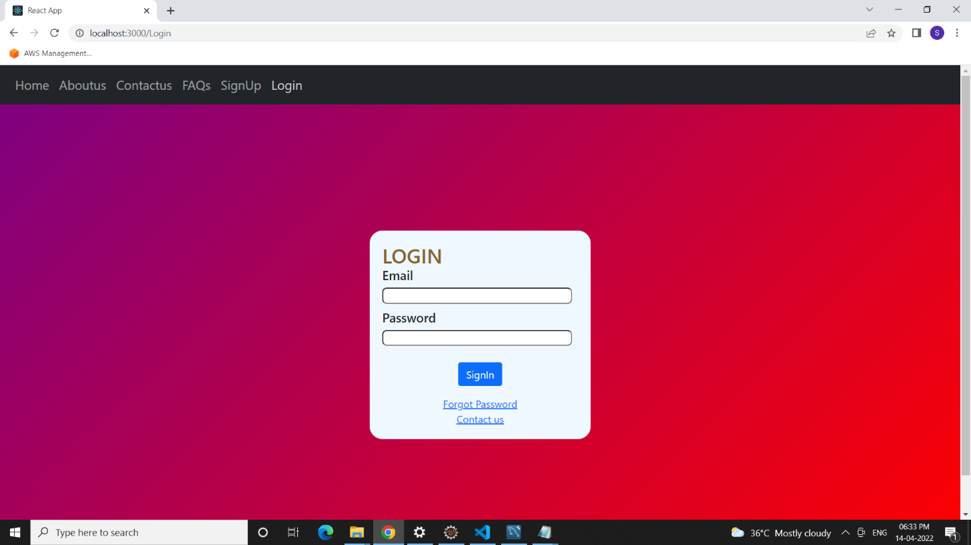

**8.5 Customer Registration Page**

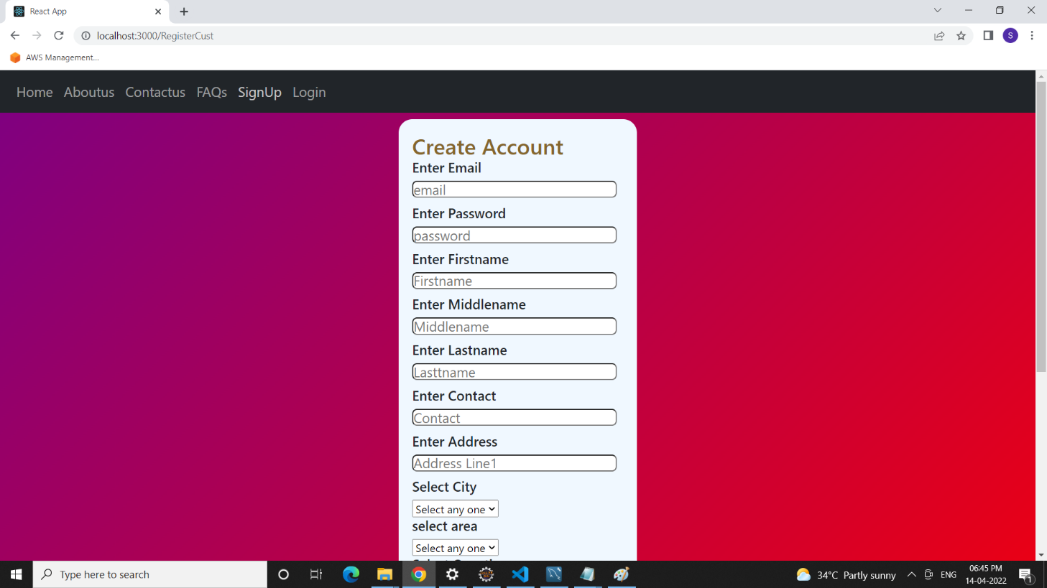

**8.6 Admin Home Page**

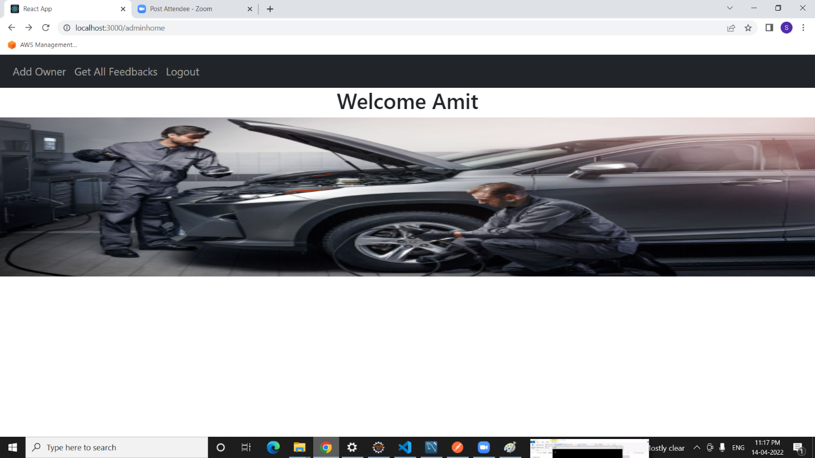

**8.7 Owner Registration Page**

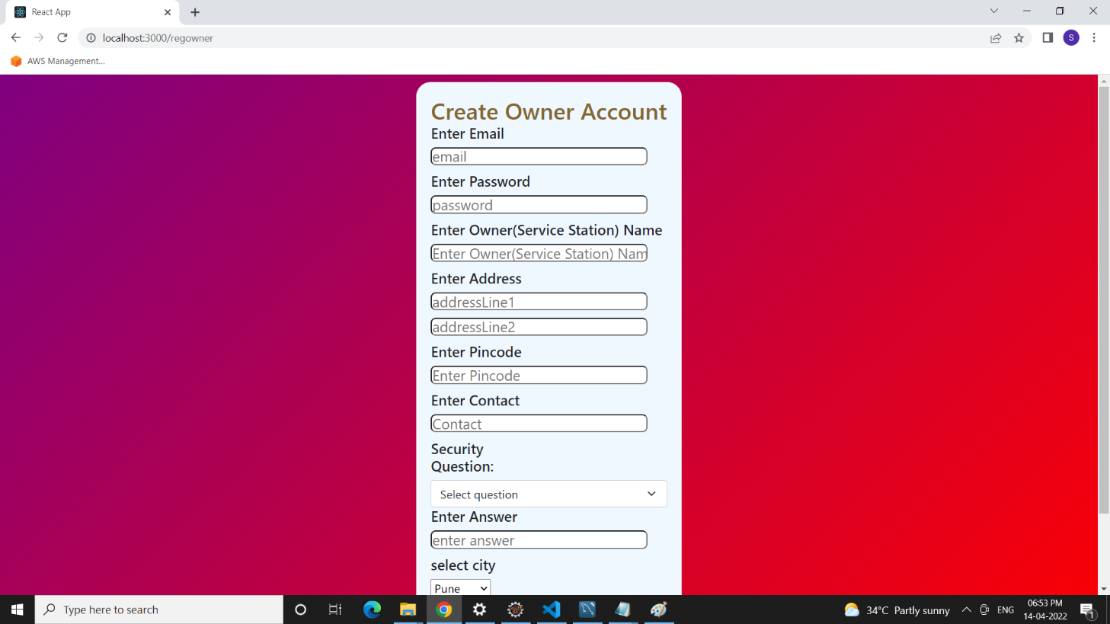

**8.8 Owner Home Page**

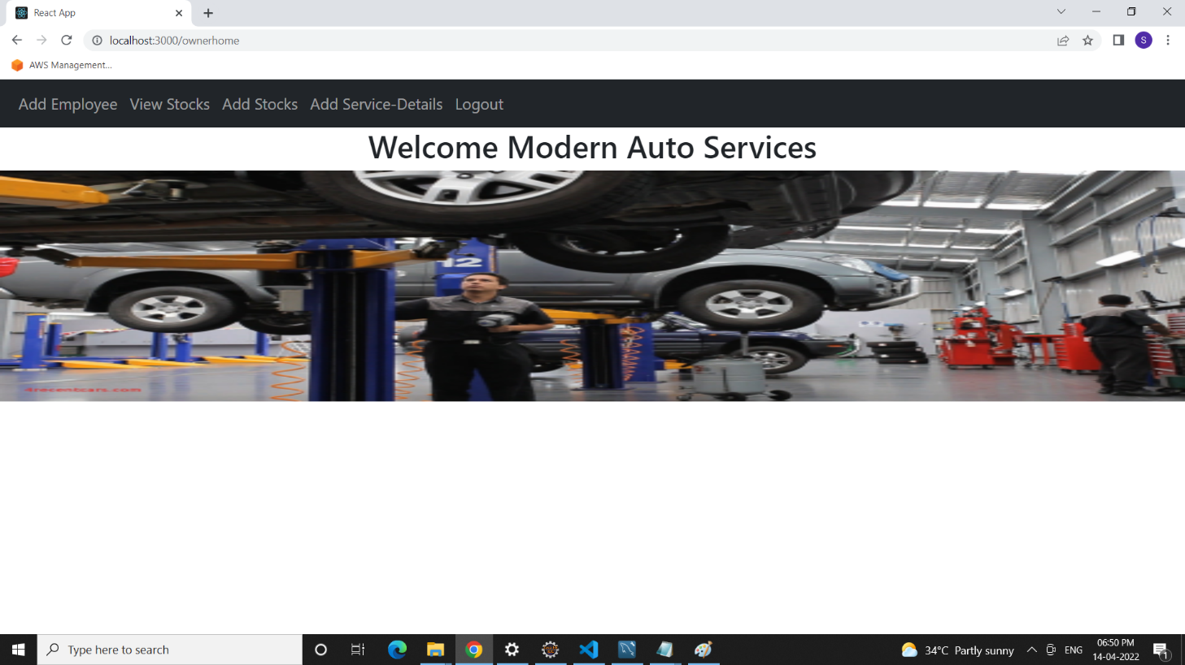

**8.9 Owner Information Page**

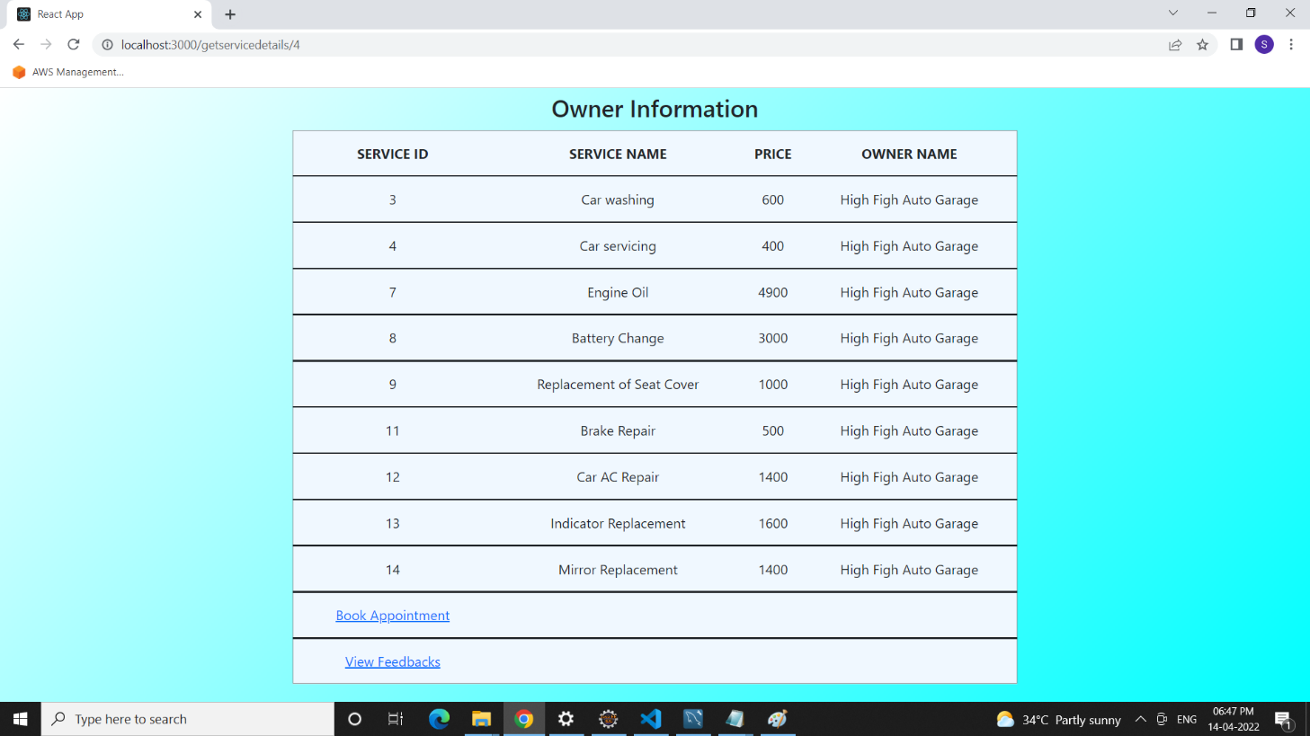

**8.10 Add Stock Page**

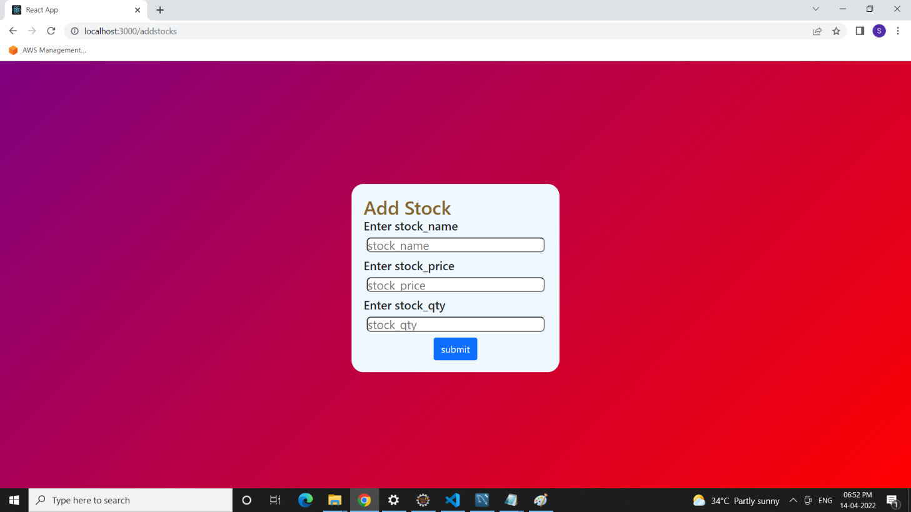

**8.11 Get Stock and Update Stock Page**

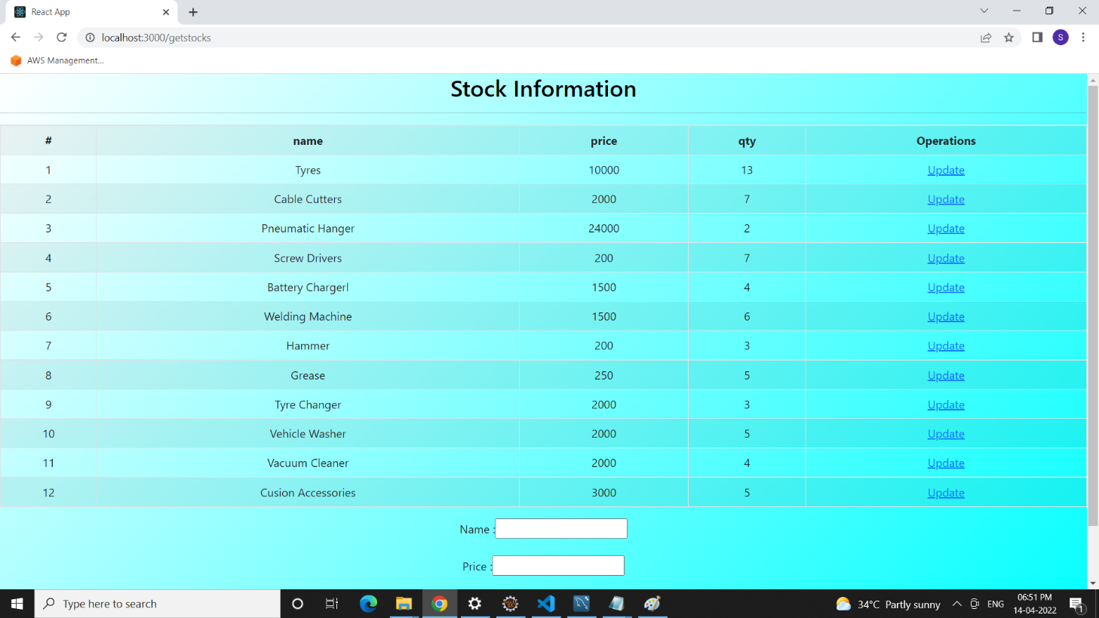

**8.12 Employee Registration Page**

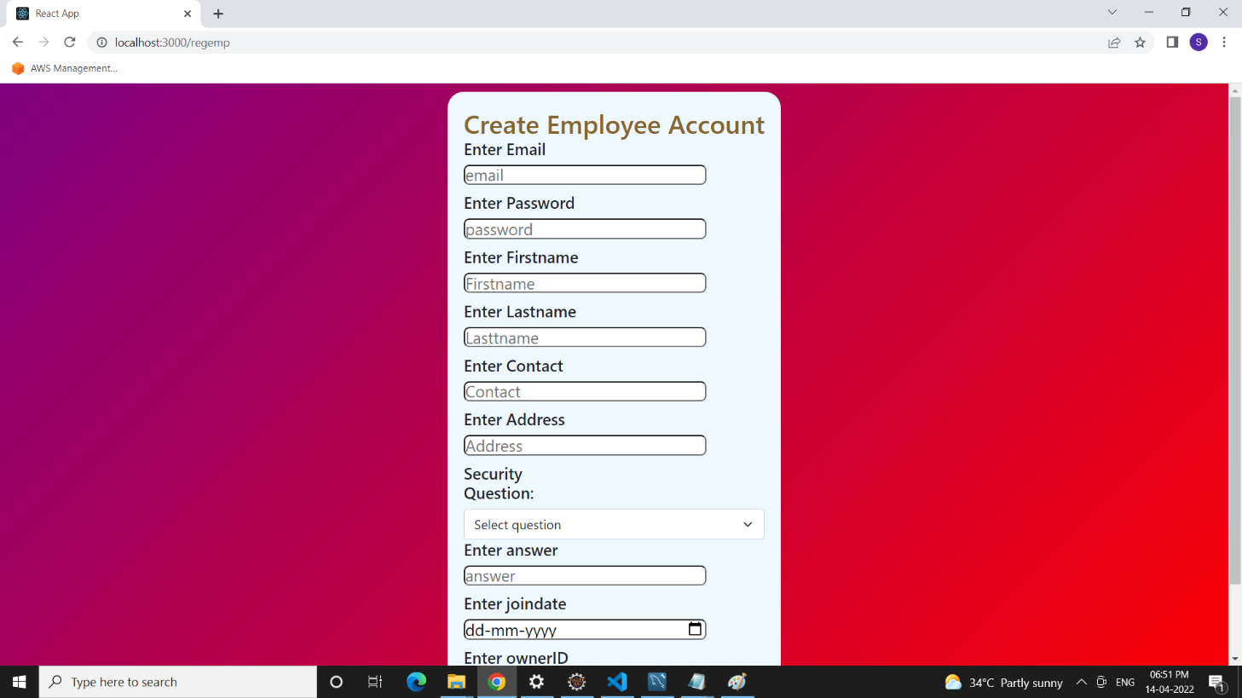

**8.13 Find Garage Page**

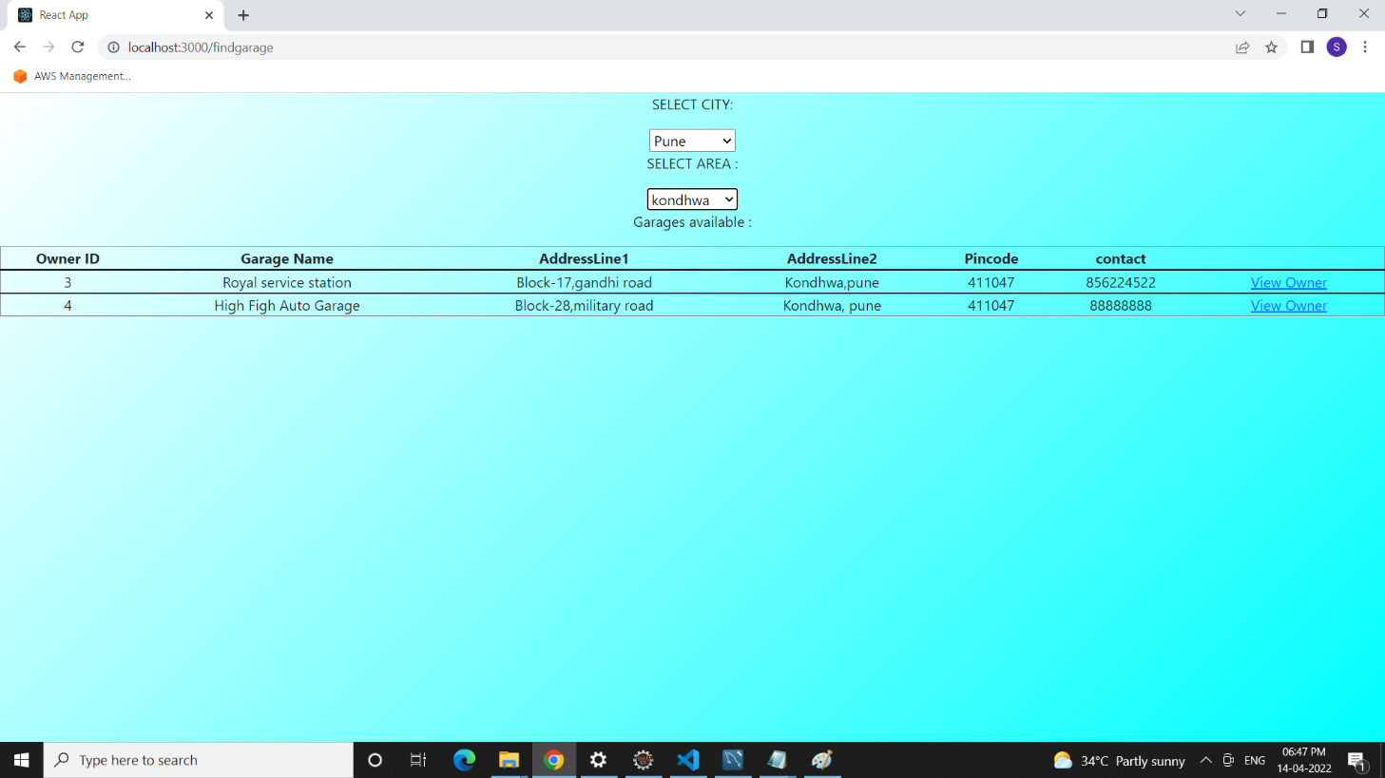

**8.14 Appointment Booking Page**

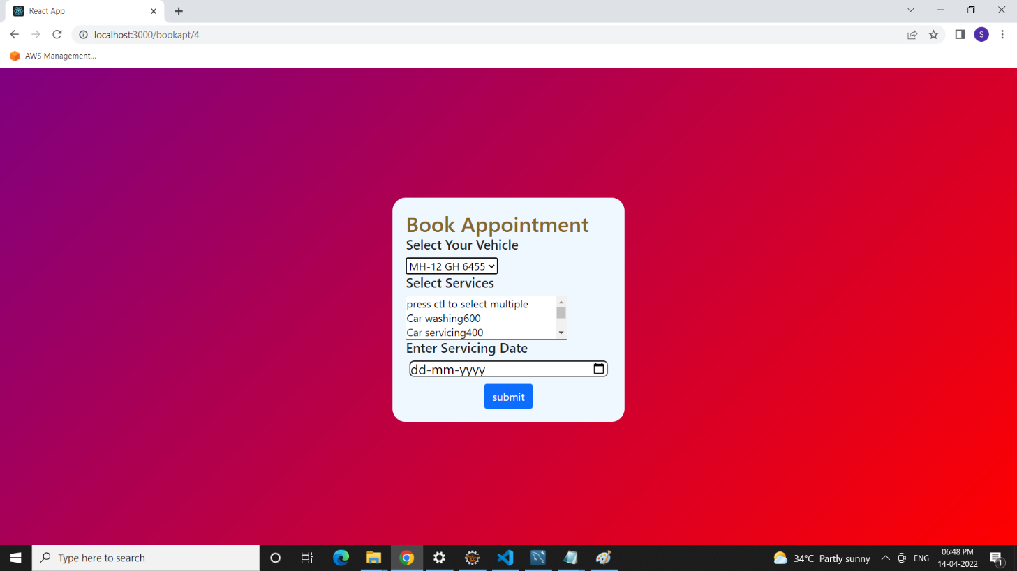

**8.15 Add Service Details Page**

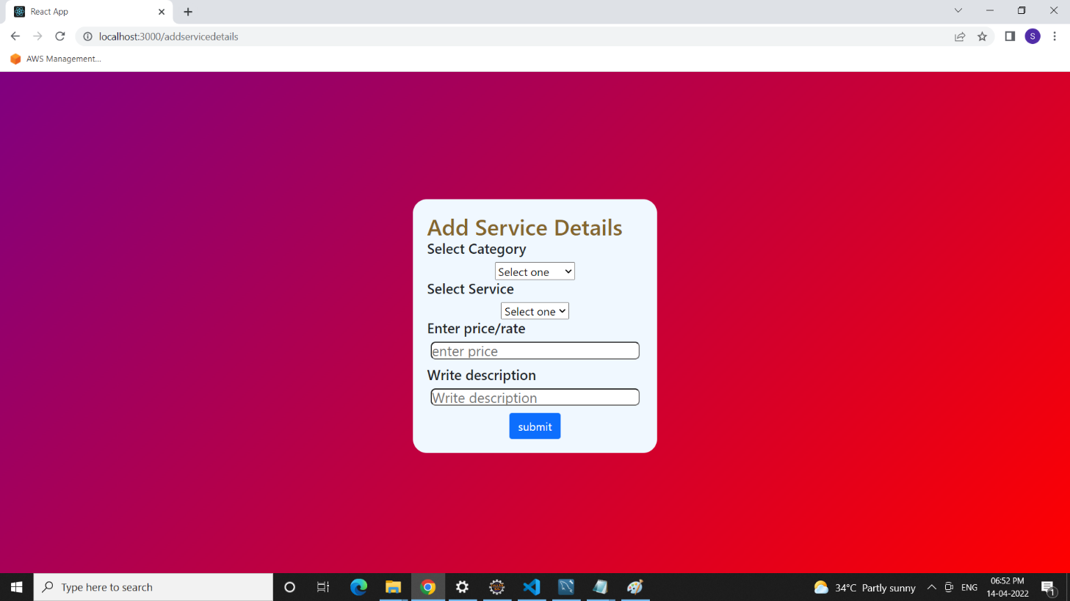

**8.16 Feedbacks Page**

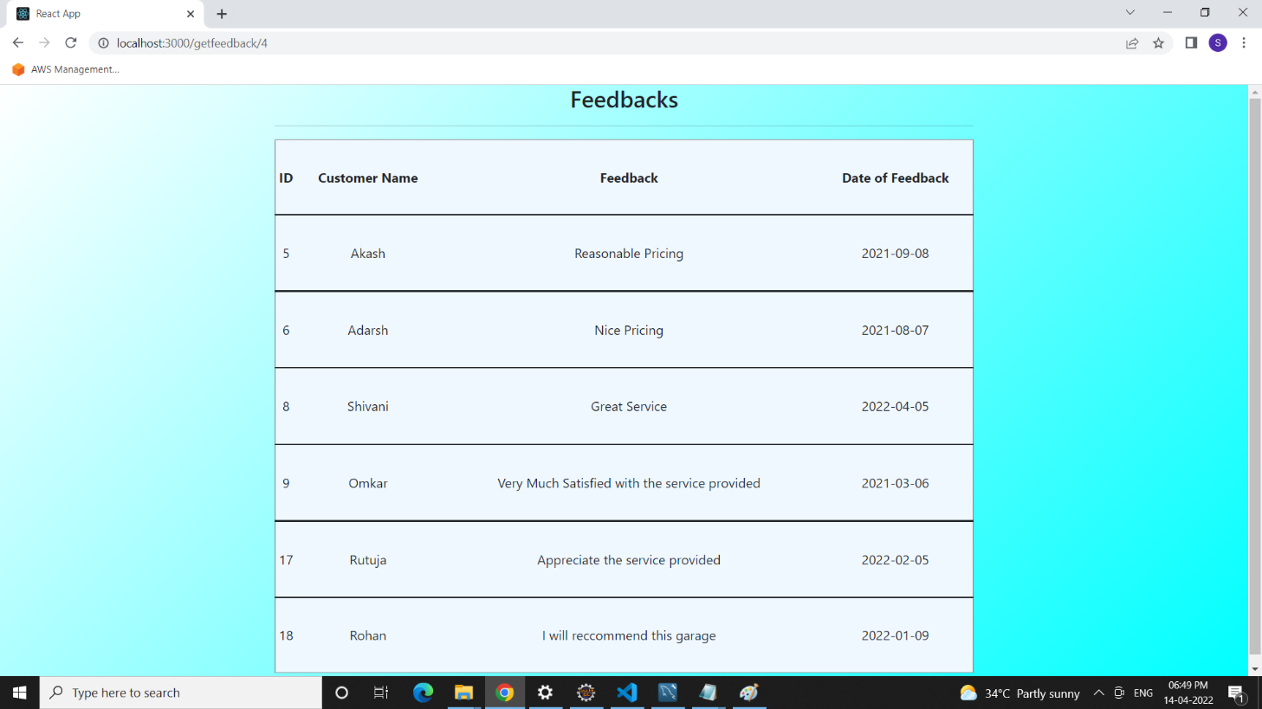

**9. CONCLUSION AND FUTURE SCOPE**

Online Vehicle Service Station provides better platform for customer to get their vehicle serviced by searching nearby service station. Customer can also watch the different services provided by different garage owners and price/rates for each service. He is also able to view the feedbacks given by other customers to nearby service centers and then can decide best suitable service station for him.